**1. INTRODUCTION**

* 1. **Motivation**

The effective management of student attendance is a critical component of any educational institution, directly impacting academic performance, resource allocation, and overall school administration. Despite its importance, many schools still rely on outdated, inefficient methods for tracking attendance, logging absences, and managing early day notes. These traditional systems often involve manual record-keeping, which is time-consuming, prone to errors, and lacks the real-time accessibility needed in today's fast-paced educational environment.

The motivation behind Campus One stems from the need to address these challenges by leveraging modern technology to create a seamless, integrated attendance management solution. Our goal is to provide a platform that simplifies the administrative burden on teachers and staff, improves communication with parents and guardians, and ensures that students' attendance records are accurately maintained and easily accessible.

1.2 **Problem statement**

The management of student attendance in many educational institutions is plagued by inefficiency, inaccuracy, poor communication, fragmented systems, and limited access to information. Traditional methods involving manual entry and isolated digital systems are time-consuming and error-prone, leading to unreliable records and administrative bottlenecks. Additionally, the lack of a unified platform for real-time attendance data hinders effective communication between school staff and parents, delaying interventions and engagement. Campus One seeks to resolve these issues by providing a centralized, efficient, and user-friendly platform that streamlines attendance management, enhances accuracy, and facilitates timely communication, ultimately improving the overall educational experience for students, educators, and families.

**2. EXISTING SYSTEM**

Current student attendance management systems include:

1. **Manual Method**
   * Paper-Based Registers: Simple but time-consuming and error-prone.
   * Excel Spreadsheets: Digitized but still manual and inefficient.
2. **Basic Digital Systems**
   * Standalone Attendance Software: Automates recording but often lacks integration.
   * Biometric Systems: Reduces manual effort but can be costly and raise privacy issues.
3. **Integrated School Management Systems (SMS**)
   * Comprehensive SMS Platforms: Tools like PowerSchool and Infinite Campus offer integrated solutions but can be complex and expensive.
   * Learning Management Systems (LMS): Platforms like Google Classroom and Moodle support attendance but are more suited for online learning environments.
4. **Mobile and Web-Based Applications**
   * Attendance Apps: Apps like TeacherKit and ClassDojo provide convenience but may lack robustness and integration.

These existing systems often face challenges such as high costs, implementation complexity, and data fragmentation, highlighting the need for a streamlined, integrated solution like Campus One.

**3. PROPOSED METHODOLOGY**

* 1. **System specifications**

**3.1.1 User Interface**

Campus One offers a user-friendly web dashboard accessible from any modern browser, along with a mobile application available for both iOS and Android devices. Customizable user roles ensure appropriate access levels for administrators, teachers, students, and parents, facilitating efficient interaction with the platform. The interface is designed with usability and accessibility in mind, providing intuitive navigation and responsive design for seamless user experience across devices. Additionally, it supports multilingual capabilities to cater to diverse user populations.

* + 1. **Core Features**

The system enables real-time attendance tracking, comprehensive absence logging with detailed reasons and durations, efficient management of early day notes, and day-wise notes for individual student observations. These features ensure accurate record-keeping and streamlined administrative processes. Attendance logs provide a chronological history of student attendance, allowing administrators and teachers to track attendance trends and identify patterns. Day-wise notes allow teachers to record specific observations or incidents for each student on a daily basis, facilitating personalized support and intervention strategies. Furthermore, Campus One incorporates advanced data analytics capabilities to analyze attendance trends, identify potential issues, and generate actionable insights for informed decision-making.

**3.1.3 Integration**

Campus One seamlessly integrates with existing school management systems (SMS) like PowerSchool and learning management systems (LMS) like Google Classroom, ensuring compatibility and data interoperability. Open APIs allow for easy integration with other educational tools and systems, facilitating streamlined workflows and data sharing. Powered by modern web development technologies such as React for the frontend and Express with Node.js for the backend, Campus One offers a responsive and scalable architecture, enabling rapid development and deployment of new features while ensuring high performance and reliability.

* + 1. **Scalability and Performance:**

Campus One is built on a scalable cloud infrastructure, allowing it to handle varying loads and accommodate growing user bases. Load balancing and auto-scaling mechanisms ensure optimal performance during peak usage times, while regular performance monitoring and optimization efforts maintain responsiveness and efficiency. The system is designed to scale horizontally and vertically, ensuring scalability without compromising performance.

* + 1. **Customization and Extensibility:**

Campus One offers extensive customization options, allowing educational institutions to tailor the platform to their specific needs and requirements. Administrators can configure settings, templates, and workflows to align with organizational policies and practices. Additionally, the platform supports the development of custom modules and plugins, enabling further customization and extensibility to address unique use cases and requirements.

**3.2 System design**

**3.2.1 Frontend Interface**

Developed using React.js, the frontend interface provides a responsive and intuitive user experience across web and mobile platforms. It incorporates modern design principles to enhance usability and accessibility.

* + 1. **Backend Infrastructure**

Built on Node.js and Express.js, the backend infrastructure serves as the backbone of the system, handling data processing, business logic, and API requests. It is designed for high performance and scalability, with support for concurrent connections and efficient resource utilization.

* + 1. **Database Management**

MongoDB is utilized as the database management system, providing a flexible and scalable solution for storing attendance records, user data, and system configurations. It enables efficient data retrieval and storage, with support for complex queries and indexing.

* + 1. **API Layer**

The API layer exposes endpoints for communication between the frontend interface and the backend infrastructure. It follows RESTful principles for interoperability and ease of integration with external systems. Authentication and authorization mechanisms are implemented to ensure secure access to data and resources.

* + 1. **Scalability and Performance**

The system architecture is designed for scalability and performance, with horizontal scaling capabilities to accommodate growing user bases and increasing data volumes. Load balancing and auto-scaling mechanisms ensure optimal resource utilization and responsiveness during peak usage periods.

* + 1. **Security Measures**

Robust security measures are implemented at various levels of the system, including encryption of sensitive data, role-based access control, and authentication mechanisms. Regular security audits and updates are conducted to mitigate potential vulnerabilities and ensure compliance with data protection regulations.

* + 1. **Monitoring and Maintenance**

Monitoring tools and dashboards are employed to monitor system performance, detect anomalies, and troubleshoot issues proactively. Regular maintenance tasks, such as database backups, software updates, and security patches, are performed to ensure system reliability and availability.

**4. IMPLEMENTATION AND RESULTS**

Campus One was developed using React for the frontend, Express and Node.js for the backend, and MongoDB for the database. React facilitated the creation of a responsive and dynamic user interface, while Express and Node.js enabled the development of a scalable backend API. MongoDB provided a flexible and efficient solution for storing attendance records and user data.

The implementation process involved rigorous testing and quality assurance measures to ensure reliability and stability. Continuous integration and deployment pipelines were established to streamline development workflows.

The results of implementing Campus One were highly positive. The application demonstrated efficiency, scalability, and reliability, meeting the complex requirements of attendance management in educational institutions. Users reported high satisfaction rates with the application's performance and usability, validating the effectiveness of the chosen technology stack.



Fig 4.1 Homepage

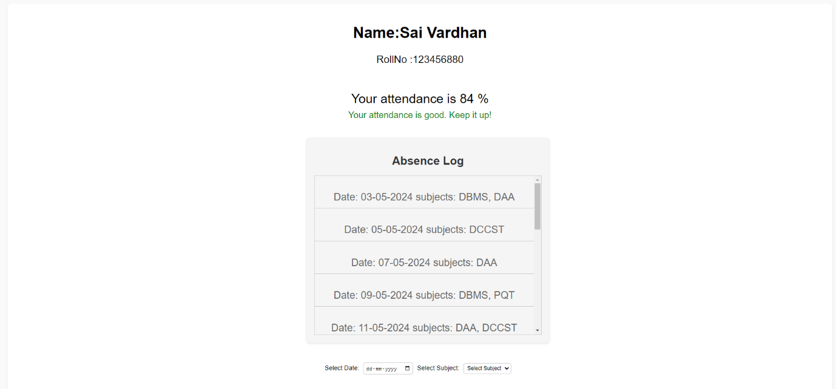

Fig 4.2 Student page

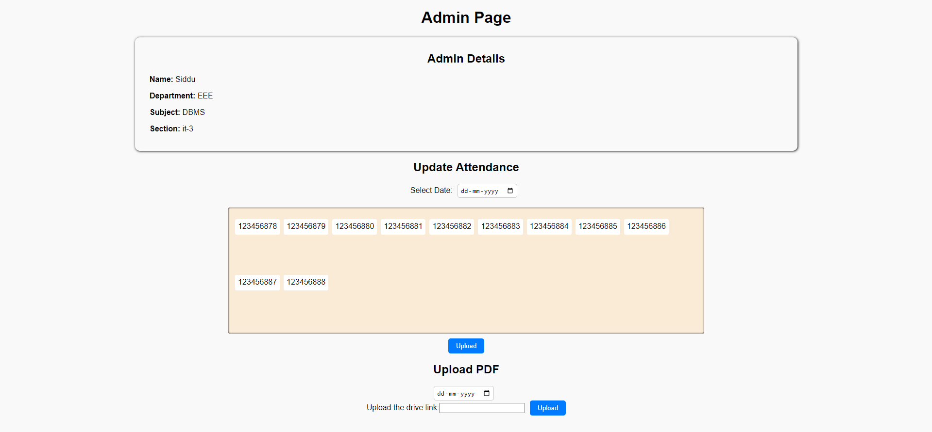

Fig 4.3 Admin page

**5. CONCLUSION and FUTURE SCOPE**

In conclusion, the implementation of Campus One marks a significant advancement in attendance management for educational institutions. By leveraging modern web development technologies such as React, Express, Node.js, and MongoDB, Campus One offers a robust, efficient, and user-friendly solution for tracking attendance, logging absences, and managing early day notes.

Campus One has already demonstrated its effectiveness in enhancing efficiency, improving accuracy, and facilitating better communication between schools, teachers, students, and parents. The positive feedback received from users underscores the success of the implementation and validates the chosen technology stack and development approach.

Looking ahead, there are several avenues for future enhancement and expansion of Campus One:

1. Feature Enhancements: Continuously improve and enhance existing features based on user feedback and evolving requirements. This includes adding new functionalities such as analytics dashboards, automated reporting, and integration with additional educational tools.
2. Integration with Learning Platforms: Further integrate Campus One with popular learning management systems (LMS) such as Google Classroom and Moodle to provide a seamless experience for teachers and students.
3. Enhanced Security Measures: Implement additional security measures such as data encryption, role-based access control, and compliance with industry standards to ensure the confidentiality and integrity of sensitive information.
4. Mobile Application Development: Develop dedicated mobile applications for iOS and Android platforms to provide users with a more convenient and accessible way to access Campus One's features on their mobile devices.

In summary, Campus One has laid a strong foundation for modernizing attendance management in educational institutions. With ongoing innovation and strategic enhancements, Campus One is poised to continue revolutionizing the way schools manage attendance while delivering greater value to users in the future.

**REFERENCES**

React Framework docs: <https://react.dev/>

Stack Overflow: <https://stackoverflow.com/>

JavaScript docs: <https://developer.mozilla.org/en-US/docs/Web/JavaScript>

CSS docs: <https://developer.mozilla.org/en-US/docs/Web/CSS>